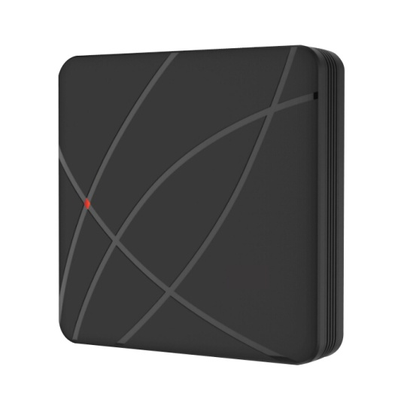**读卡器U-P004**

**产品特点：**

◆产品材质：塑料外壳

◆超低功耗：待机电流小于30mA。

◆输出格式：WG26/34

。

**product presentation**

◆Product Material: plastic housing

◆Very low power consumption: static current less than 30mA.

◆Output format: WG26/ 34

**技术参数：**

|  |  |
| --- | --- |
| 读卡类型：EM/MF | 防水等级：IP/68 |
| 工作电压：DC9-16V | 静态电流：≤30mA |
| 读卡距离: 3 - 8cm | 环境温度：-45～60℃ |
| 环境湿度：10%- 90% RH | 外形尺寸：86 * 86 * 19mm |

**Specifications：**

|  |  |
| --- | --- |
| Card type：EM/MF | Waterproof degree:IP68 |
| Working voltage: DC12V±10% | Static electricity: ≤30mA |
| Read Range:5-8cm | Ambient temperature: -45 ℃ ~ 60 ℃ |
| Humidity: 10% to 90% | Dimensions: 86 *86* 19mm |